Project Design Phase
Solution Architecture

Date | 18 February 2026
Team ID | LTVIP2026TMIDS78786
Project Name | Electric Motor Temperature Prediction System
Maximum Marks | 4 Marks

Solution Architecture:
Overview
The solution architecture defines how the electric motor temperature prediction system is designed to transform raw sensor data into accurate temperature predictions and deliver them through a web interface.
The architecture bridges the gap between the industrial problem (motor overheating) and the technological solution (Machine Learning + Flask deployment).
The system consists of:
- Data Layer
- Processing Layer
- Machine Learning Layer
- Deployment Layer
- User Interface Layer

High-Level Architecture Description
- The proposed solution works in the following stages:
- Historical motor sensor data is collected.
- Data preprocessing is performed.
- Machine learning models are trained.
- Best model is selected (Decision Tree Regressor).
- Model is saved using pickle.
- Flask application loads the model.
- User inputs motor parameters.
- Scaler transforms input.
- Model predicts rotor temperature.
- Result is displayed on UI.

Example - Solution Architecture Diagram:

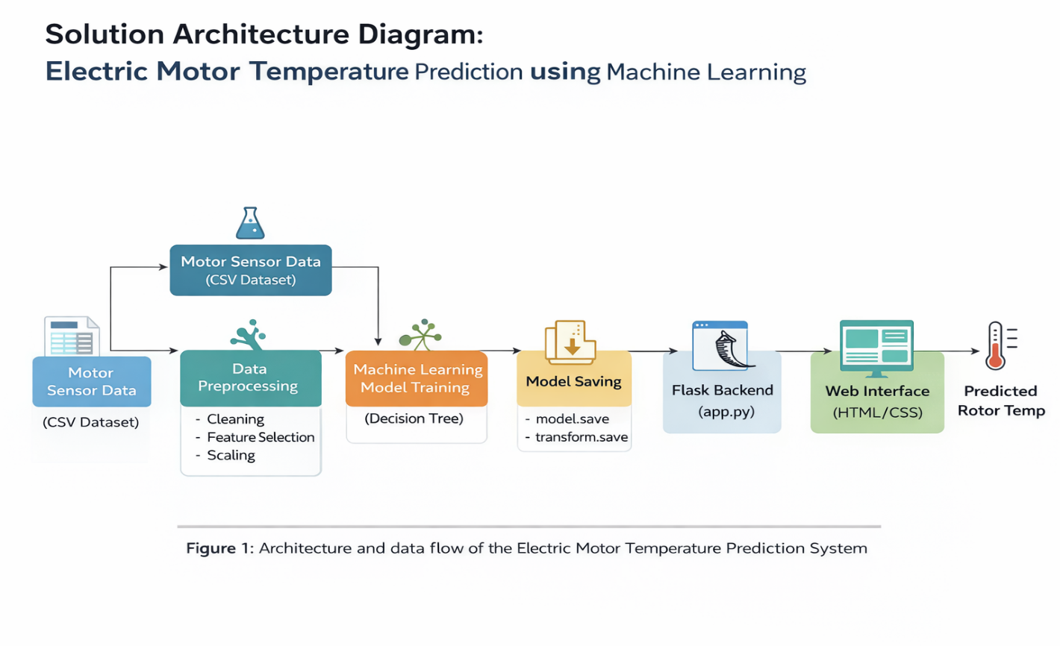
Data Layer
The dataset contains motor operational parameters including voltage, current, motor speed, ambient temperature, and stator temperatures
Preprocessing Layer
The preprocessing stage includes:
- Removing unnecessary columns
- Handling missing values
- Feature scaling using MinMaxScaler
- Splitting data into training and testing sets

Machine Learning Layer
Multiple regression models are trained:
- Linear Regression
- Decision Tree
- Random Forest
- SVR
The Decision Tree Regressor is selected based on highest R² score (~96%).
Presentation Layer
The frontend is built using HTML and CSS, providing:
- Manual prediction interface
- Sensor-based prediction module (future scope)
- Result display section
Data Flow Explanation
- User enters motor parameters.
- Flask receives input.
- Input is converted into numeric format.
- MinMaxScaler normalizes the data.
- Decision Tree model predicts rotor temperature.
- Prediction is displayed on the web page.
Security & Reliability
- Model file stored locally
- Input validation implemented
- Error handling mechanism included
- Scalable architecture for IoT integration

